

<Background on the launch: why did we decide to create this feature/product/part of the product, what was the problem we saw and why we decided to solve it>

Healthcare costs continue to rise at an alarming rate, particularly in the United States. This issue presents a major challenge for patients, healthcare and pharmaceutical industries. Kaiser Pamanente (KP), a leading healthcare provider in the US, wants to explore preventative solutions through technological innovations. This is an approach that promotes healthy habits, which in return, reduce and possibly eliminates the development of chronic disease, coupled with reduction in cost of diagnosis and treatment of such illness.

Chronic disease such as Diabetes is affecting quality of lives significantly across age categories. It is a disease that causes damage to large blood vessels of the heart, brain and legs. Also, to small blood vessels, causing problems in the eyes, kidneys, feet and nerves (macrovascular complications). Due to the nature of the disease and how widely spread in the society, the cost of diagnosis and treatment is increasingly high. Healthcare and pharmaceutical industries are faced with uncontrollable costs, projecting 26% increase over a five year period. According to healthcare statistics, about 33 percent of American adults could have diabetes by the year 2050. Americans will spend $3.65 trillion on health, which amounts to 17.8% of the country’s GDP. The estimated average cost of healthcare in a year is about $10, 300 per person.

<What exactly we launched: description of the product or feature and what it does and how it solves the problem described above>

We launched Healthy Living Partner, which is a subscription based mobile app that monitors, tracks, and recommends diet and exercise activities. It provides user performance data analysis, as well as Application Programming Interface (API) for integration with other complimentary products.

Product Features

1. Blood sugar-level monitor
2. Diet Assistant
3. Exercise Activity Mate
4. Performance Monitor
5. Application Programming Interface(API)

For wellness and healthy lifestyle enthusiasts that want to take advantage of state- of-the-art apps that offer easy and convenient access to preventative monitored diet and exercise routine, Healthy Living Partner is the one-stop-shop app for healthy lifestyle habits anywhere at any time. It combines all the essential components of health and wellness into one.

<Insert data on how your product performs: visual representation of your data, numbers, outcomes>

Below is the post-launch statistical analytics data and the feedback received.

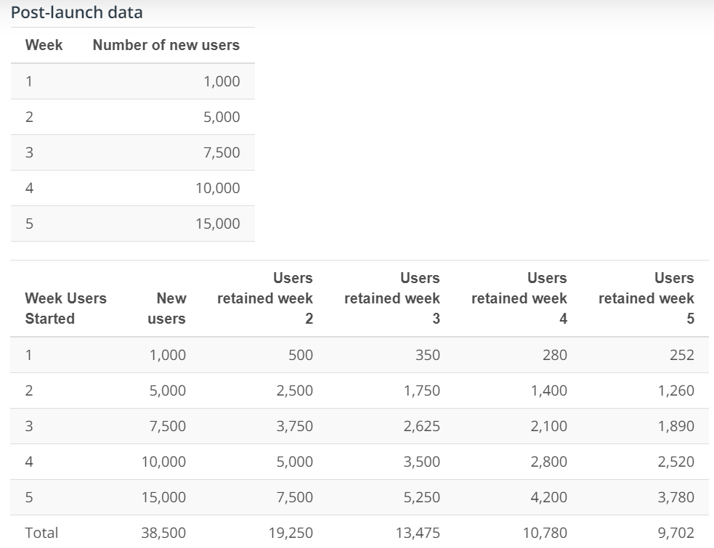

Field Feedback

Your users are adopting the app, but they are not granting you permissions for notifications (only 10% of all your users granted you notifications permissions. What can you do to improve that?

<Add a brief description of the next steps>

The next phase of the product development:

1. Review the post-launch data and arrive at necessary improvements to promote and encourage app notification to users.
2. Investigate ways to increasingly retain new and existing users
3. Iterate
4. Expand coverage for the integrated products to include more test and monitoring products. We are currently in collaboration with Kaiser Permanente (KP), but will work to include other healthcare providers in the program.

I like to thank the entire team for working diligently together to make this project a success.

Francis Odo,

on behalf of:

Design Engineers

Product Lead

QA Test Engineer

Legal and Compliance

Development Team

Product Marketing

Customer Support